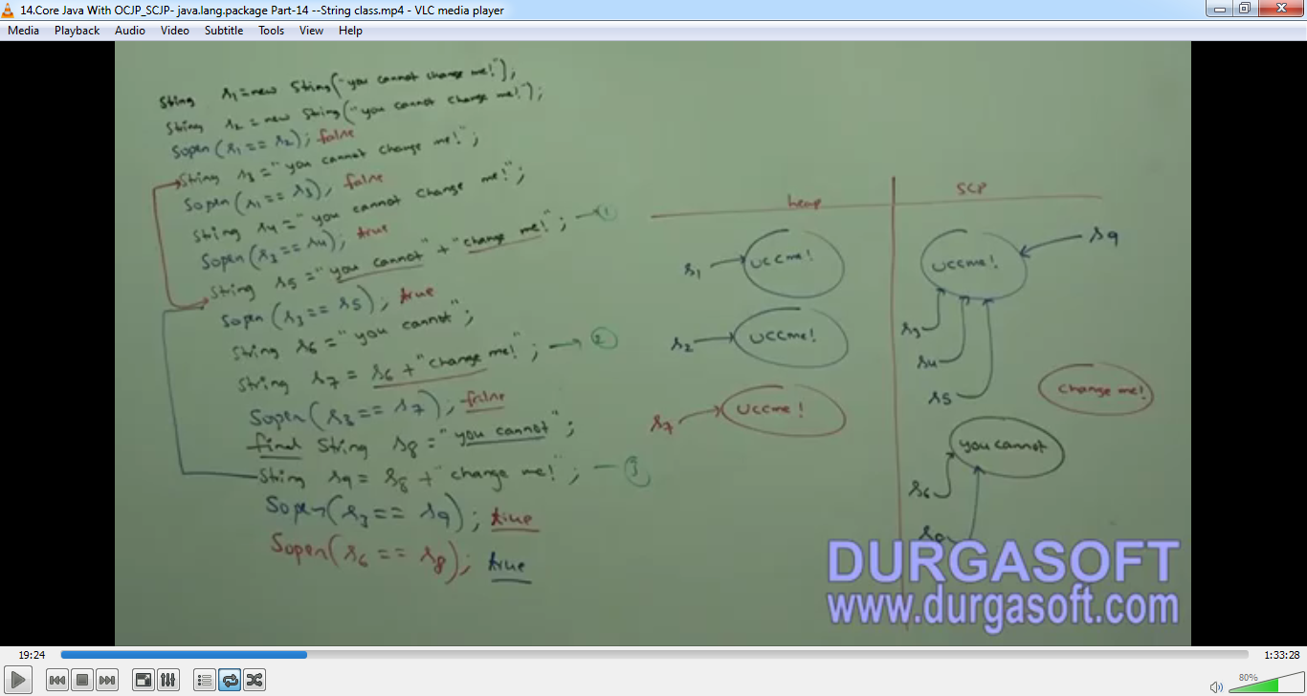



interning of String object intern()

1. intern()
   1. By using heap object reference, if we want to get SCP (String Constant Pool) object reference, then we should go for intern().
   2. **Example**:   
      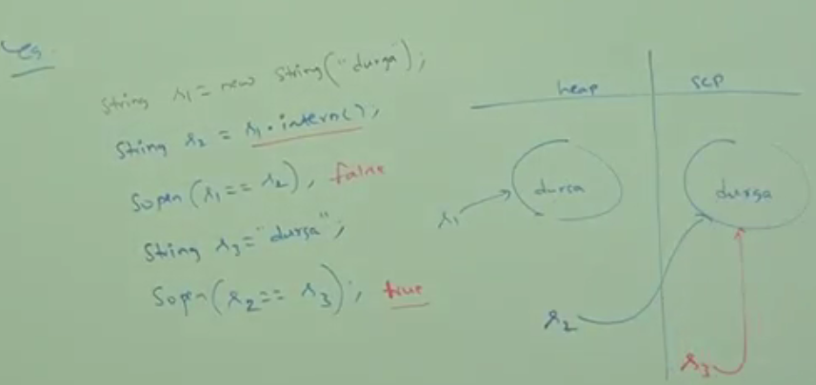
   3. if the corresponding scp object is not available, then intern() will itself create the corresponding scp object.  
      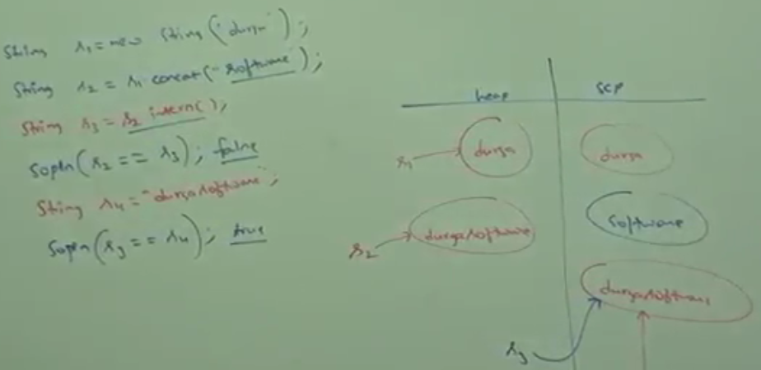
2. d

Advantage and Disadvantage of SCP(String Constant Pool)

1. **Advantages**:
   1. Memory Improvement
   2. Performance increment  
      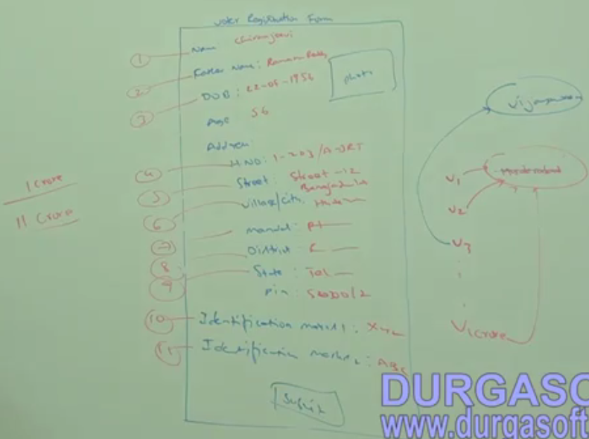
2. **Disadvantes**:
   1. For every change to string, a new string object is created.
3. d

Interview Questions



**Anwers**:

1. d
2. d
3. d
4. d
5. Specially designed memory area called buffer for string objects.
6. Memory Utility, Performance improvement
7. For every change to String, a new string is created.
8. String is the most commonly used object and hence Sun people provided special memory management for string. But Stringbuffer is not commonly used object and hence special memory management is not required.
9. String: Because of SCP (String Constant Pool), a single object can be referenced by multiple references. By using one reference, if we are allowed to change the content in the existing object, then remaining references will be affected. To overcome this problem, Sun people implemented String object as immutable. According to this, once we create a String object, we can’t perform any changes in the existing object. If we are trying to perform any changes, with those changes, a new String object will be created. But in StringBuffer there is no concept like SCP, hence for every requirement a separate object will be created. By using one reference, we are trying to change the content then there is no effect on the other references. Hence, immutability concept for the StringBuffer is not required.
10. All wrapper class objects
11. Yes ☺